

# **SEG Entry 3 Level Award in Reading & Writing in Spanish**

**Unit title:** Writing in Spanish **Task:** 4  **Assessment criteria:** 2.1

**Language & course ref:** Spanish **Date:** / /

**Learner: Tutor: Flor de Andrews**

**Writing 2.1:** Write a basic message/note in Spanish conveying at least one piece of information and one question.

**Topic:** Invitation

Write a short email in Spanish to a friend:

* Ask her how she is.
* Tell her that you are going to an exhibition/film/concert/show.
* Ask her if she wants to join you.
* Tell her the starting time of the exhibition/film/concert/show.

**You may use a dictionary if required.**

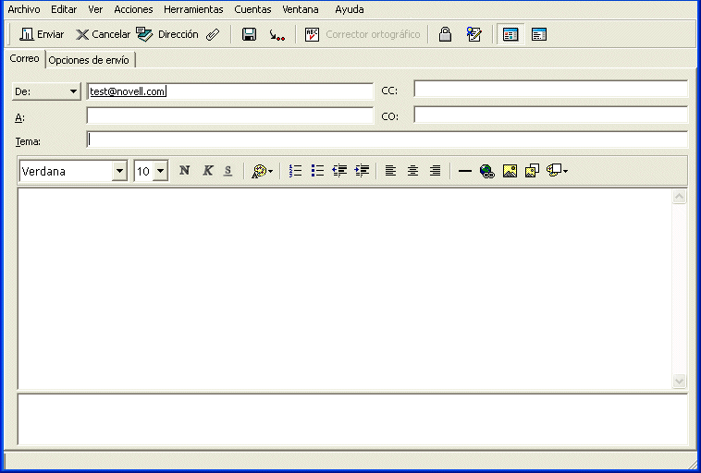

The learner has achieved the assessment criteria.

Signed ................................................. Tutor/IV Date .............................

Comments …………..………...................................................................................................

…….....................................................................................................